**Windows Server Home Lab Project**

1. Installing Active Directory on Windows Server on Virtual Machine

*Installed VMware workstation pro on my device.

Installed VMware workstation pro from BROADCOM website which is partnered with VMware. <https://knowledge.broadcom.com/external/article?articleNumber=368667>

Downloaded windows server 2022 free edition from Microsoft <https://www.microsoft.com/en-us/evalcenter/download-windows-server-2022>

Once it downloaded fully, create a virtual machine in VMware work station pro.

We need to do some specific configurations like hard disk and CPU, before finishing the setup.

After clicking finish this screen shows up.

Right click on windows server and add ISO image file by going to settings option.

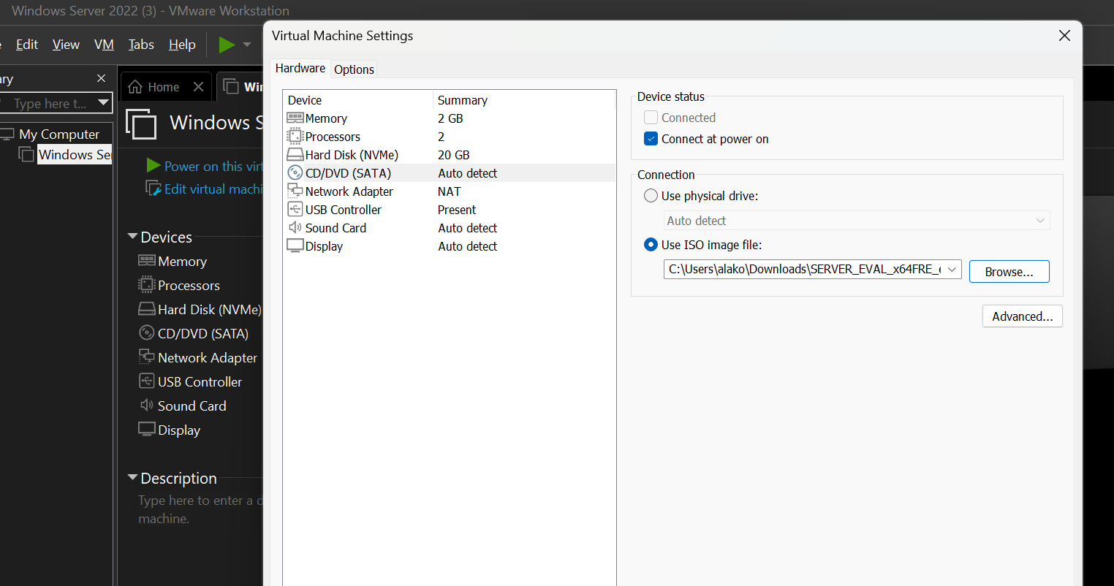

Click on Power on this virtual machine to boot the iso image file.

Once it boots up make some basic settings.

We are choosing this edition because we want the edition with graphical user interface.

After all the loading and installing, windows server gets installed on virtual machine.

Click on manage option and choose add roles and features, in features ensure remote access, Active Directory Domain Services, Group policy Management etc are turned on and then press next and confirm all the services by clicking on Install option at the bottom right.

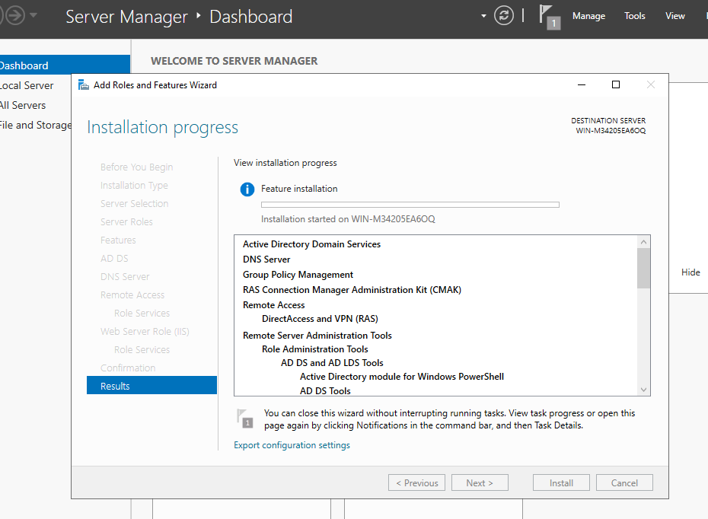

After everything is installed click on promote this machine to domain controller and give the root domain a name I’m giving some random name. Local. 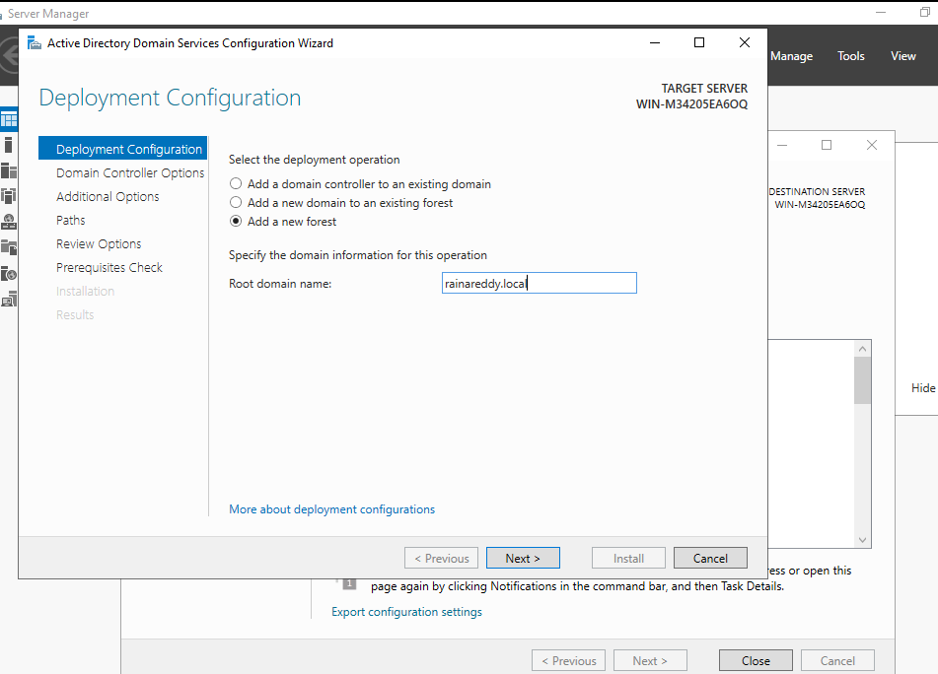

It will ask to setup a password for domain controller, after providing a password click next.

While provoding prerequisites we can see the folders where AD DS data is stored.

System restarts after all installation checks because AD DS are installed on windows server.

After restart I logged in to webserver2022 with my credentials I used during installing features.

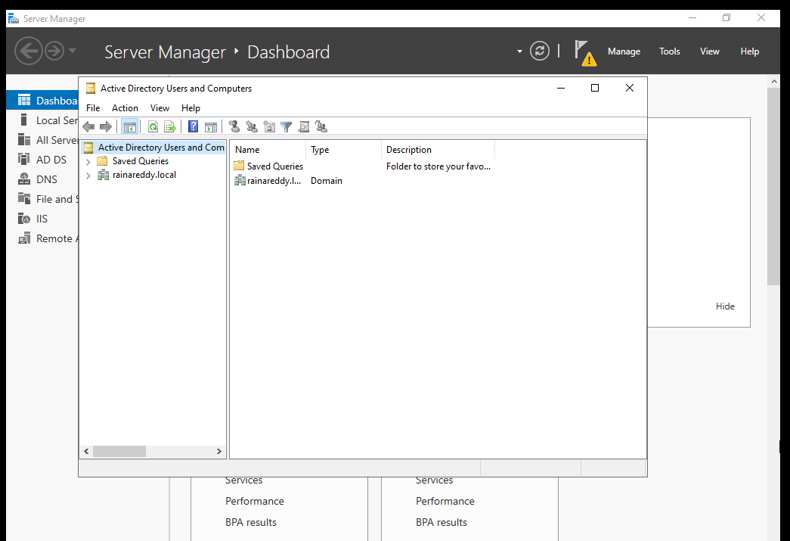

Click on windows icon and choose Active directory users and computers option.

Clicking on our domain we can see the default organisational units which comes with Active Directory.

Organizational Units are nothing but folders which contains users, groups, computers and policies.

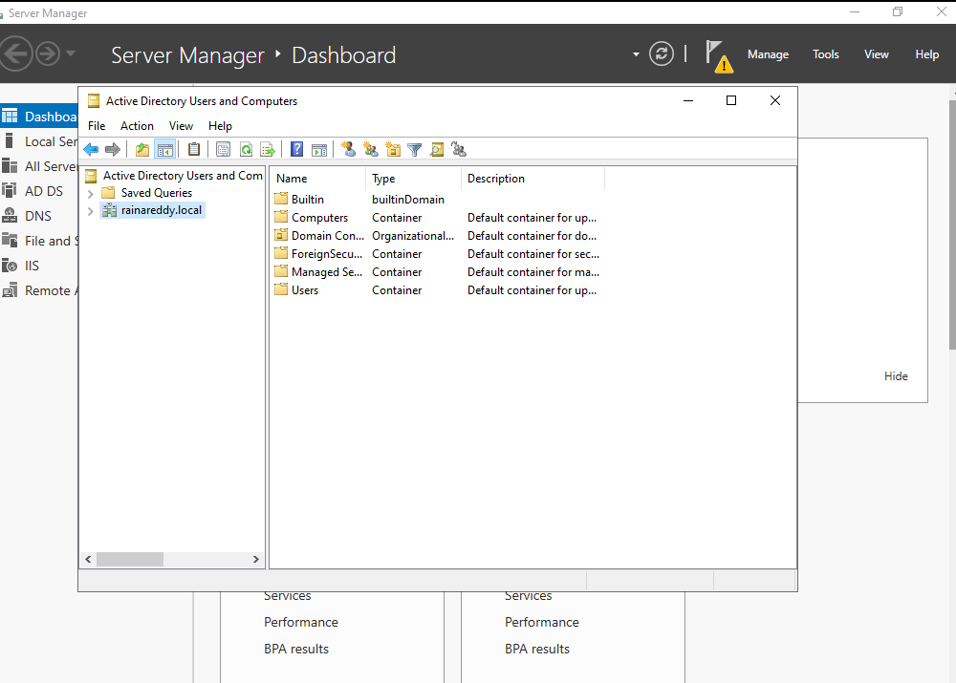

Now let us create new organizational units named USA, EUROPE and ASIA

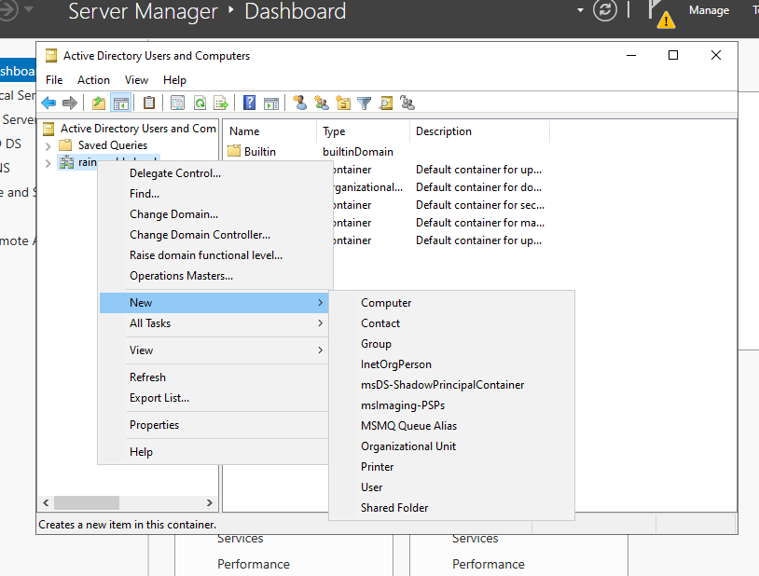

We are going to create more organizational units inside USA, ASIA and EUROPE for our better understanding of active directory.

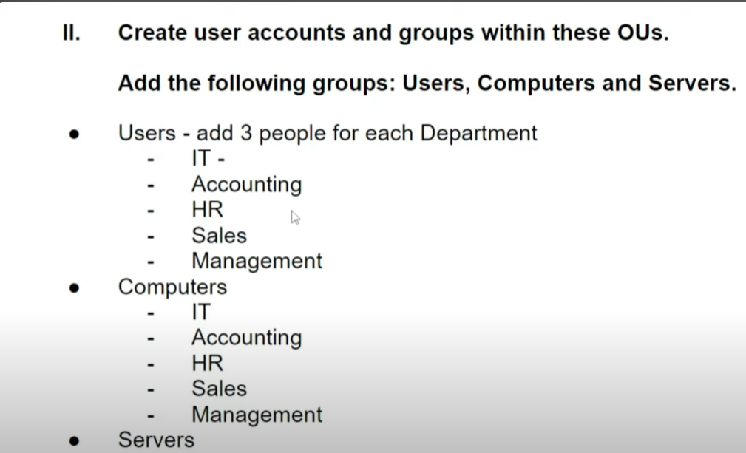

We are creating users and computers inside USA (Organizational unit) it means we can create organizational units inside an organizational unit which are called nesting/nested.

We are creating groups inside users, computers and servers to mention the departments named IT, HR etc.

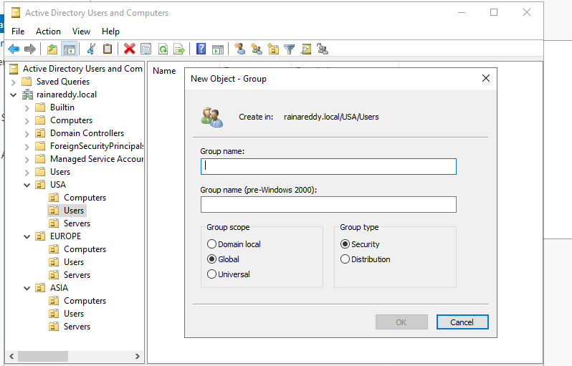



**Security groups are used to assign permissions to access shared resources.

Using custom security groups, we can customise permissions and policies.

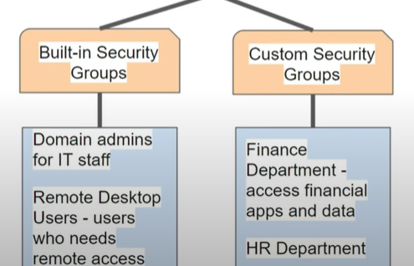

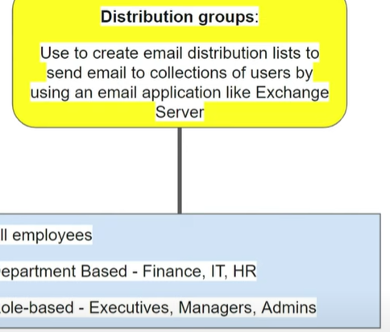ex: shared mailbox.

After that I created users, groups, computers in organisational units named USA, EUROPE and ASIA.

1. GROUP POLICY MANAGEMENT-

Creating and setting up GPO.

We have installed group policy management during the server installation, so we can find it in our windows server to configure GPO’s.

Group policy objects are managed by Admins to configure settings and permissions on users, groups and computers.

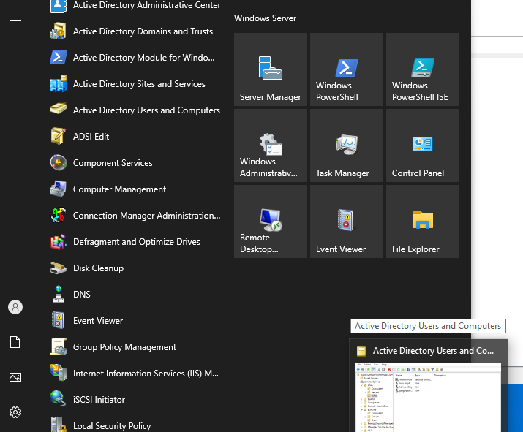



We can see default domain controller and domain policy where we can edit them or create new policies once GPM editor opens.

Two types of configurations in GPM.

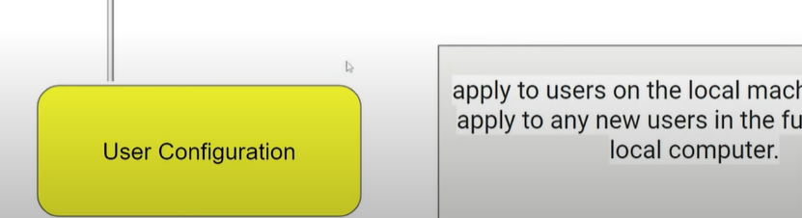

*Under configurations we have policies and preferences, where policies cannot be changed by users (password and account lockout policies) and preferences can be changed based on the usage (mapped drive, printers and desktop shortcuts).

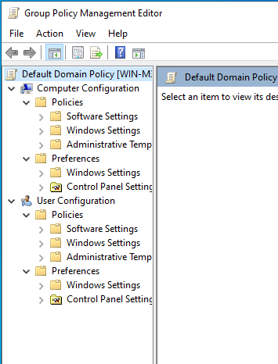

We need to right click on our domain and should choose to create a GPO in this domain.

We need to mention a name for our GPO for example, Password Policy, Account Lockout Policy, Mapped drive etc.

Once the Policy Object is made we need to right click on it, to edit it the GPO.

During edit we need to choose the configuration type whether its computer configuration or User Configuration.Password policy comes under security setting.

our GPO password policy is fully implemented with the above policies.

The second GPO we are going to setup is Drive Mapping.

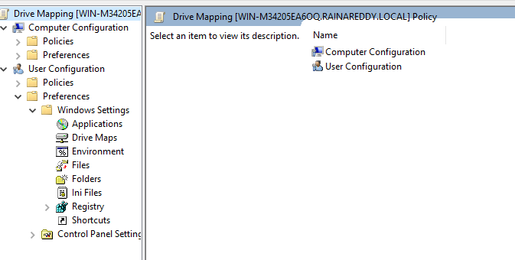

We choose user configuration because we are going to setup drive mapping for users in our domain.

Drive maps GPO is implemented.

As made above I will create a GPO which will implement Default Desktop Wallpaper for all the users.

I opted for user configuration and selected policies under user configuration because wallpaper should not be edited by user except admin.

And the last GPO I am going to create is Disable USB Devices.

Its computer configuration and it is a policy based rather than preferences.

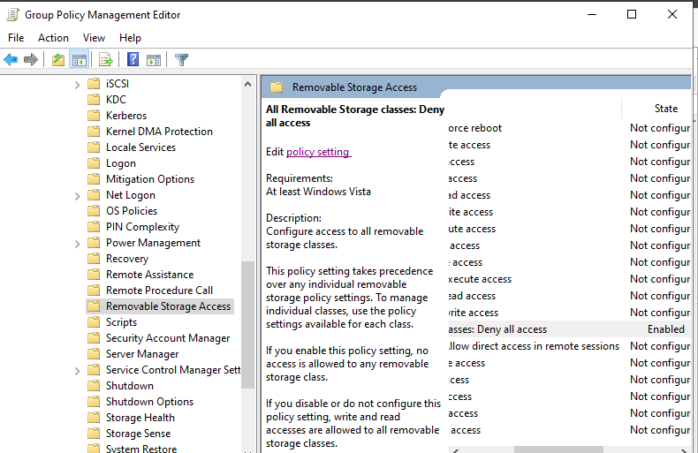

In conclusion these are all the GPO’s created by me to effectively use them in next steps.



1. Applying and Testing GPO, Adding Computers to Domain.

For this section the prerequisites are a virtual machine or a computer to test the GPO’s.

So, we are going to download a windows machine from Microsoft website and installing it in VMware Workstation player.

Link for downloading free trial version of windows 10 enterprise

<https://www.microsoft.com/en-us/evalcenter/download-windows-10-enterprise>

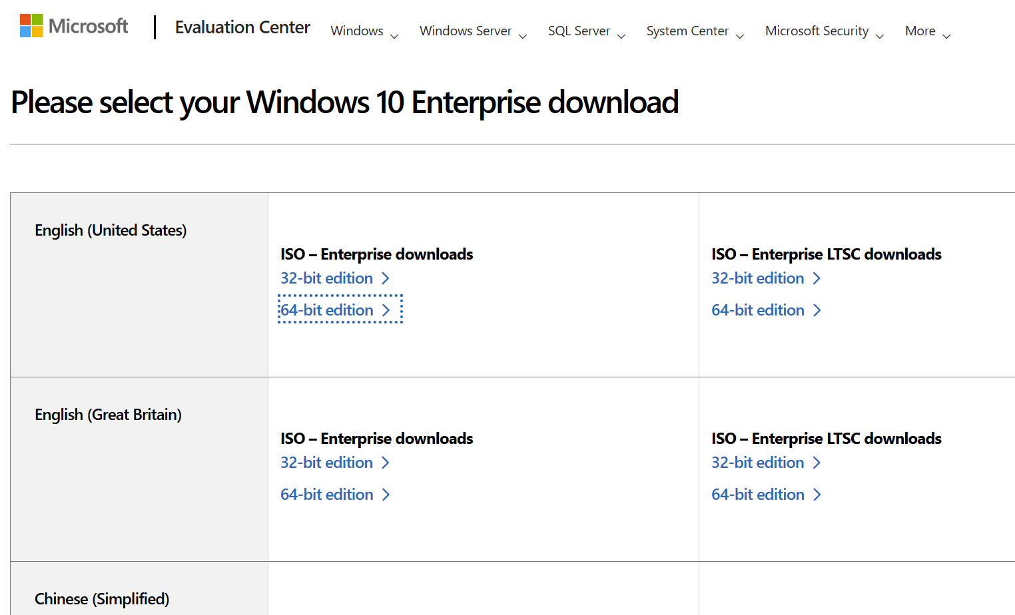

While the ISO file is downloading, we need to create a virtual machine to host windows 10 enterprise machine.

After clicking finish we can see the virtual machine that got created, so in the next step we need to upload the iso image file.

We need to go to settings tab by right clicking on it and the following page opens

Upload the iso image file in CD/DVD option, press ok and power on the VM.

Once the iso image file boots up the windows screen pops up and then continue configuring basic settings like country, language and disk partition etc.

After installing provide a password for the windows10 machine.

Click on Domain join instead because we are going to add this PC to our domain (Rainareddy.local).



After providing a username and password, it will ask some basic security questions before the machine gets ready to use. 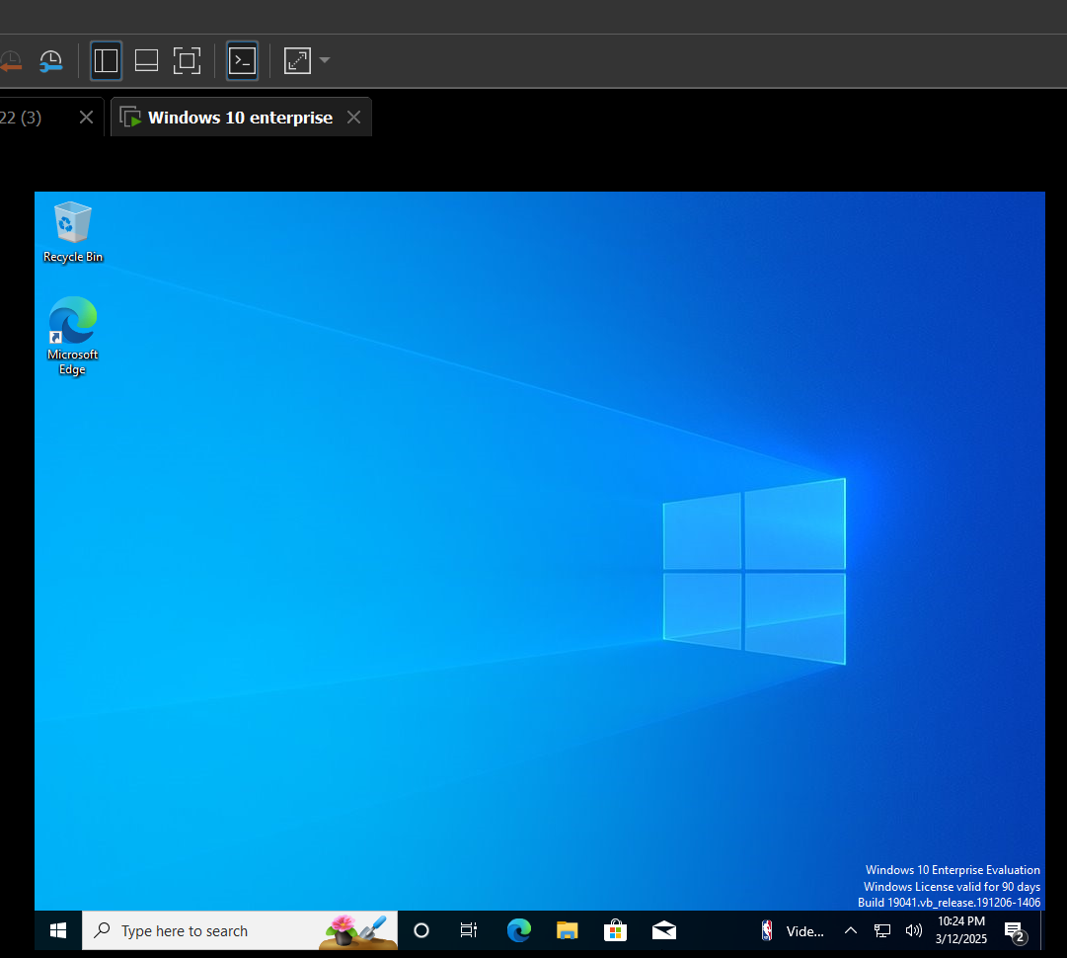

After sysytem is ready to add to the domain we need to configure dns on this machine to connect to our domain(rainareddy.local) on windows server we installed in the above process.

Login to windows server and configure static IP address.

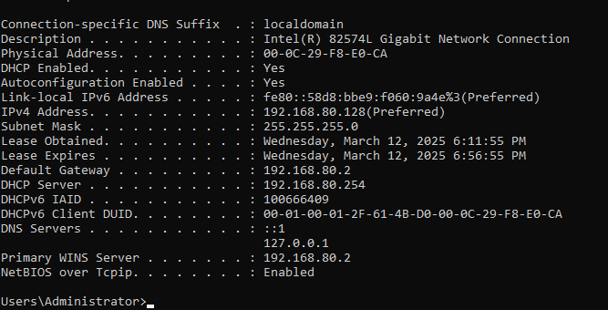Lets use this prefered ip address as static ip address and 127.0.0.1 as DNS server. Which makes us easy to connect to server.



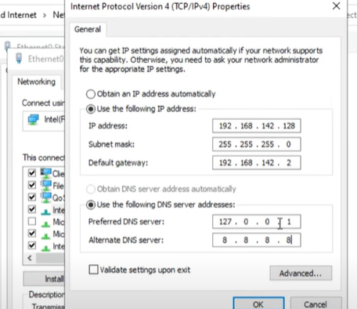settings are made in ethernet properties.



We can also make this settings through command prompt using netsh commands.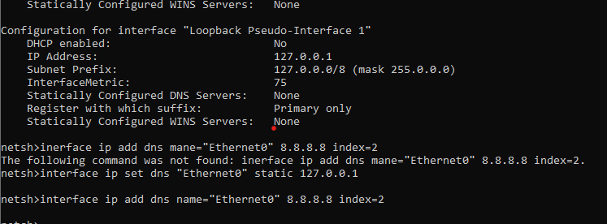

After windows server is configured with static IP, alternative DNS and DNS server, now we need to configure DNS server of windows client computer with static ip address of windows server to establish a connection between the server and client. 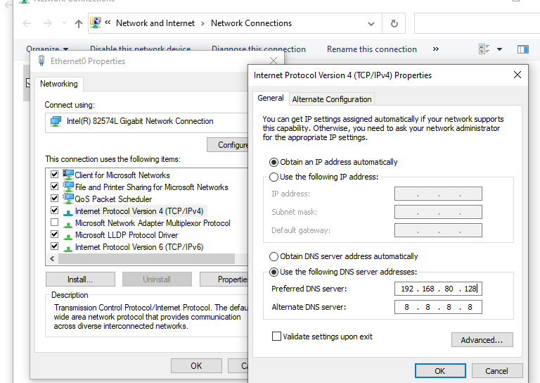click ok and check connectivity using ping command in cmd. DNS server check using nslookup.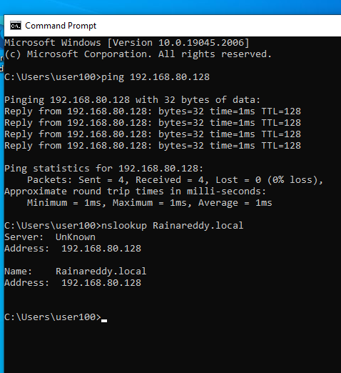



We need to go to this PC option and click on Rename(advanced) then a screen pops up where we need to mention a name for this PC and provide a domain name where we want it to connect to.

Once it successfully connected to domain we need to restart to apply these changes.

After that login into PC using any user we created in our windows server active directory.

I am going to try a user named bhanu danny created in organisational unit called Europe.

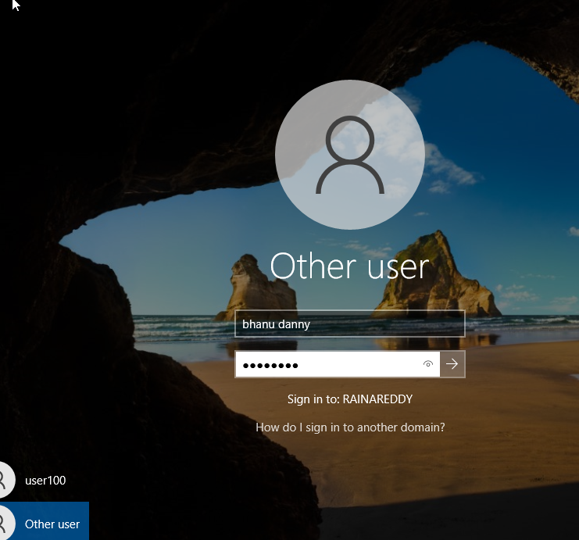

After I logged in successfully this screen appears, and now we can start the GPO’s.

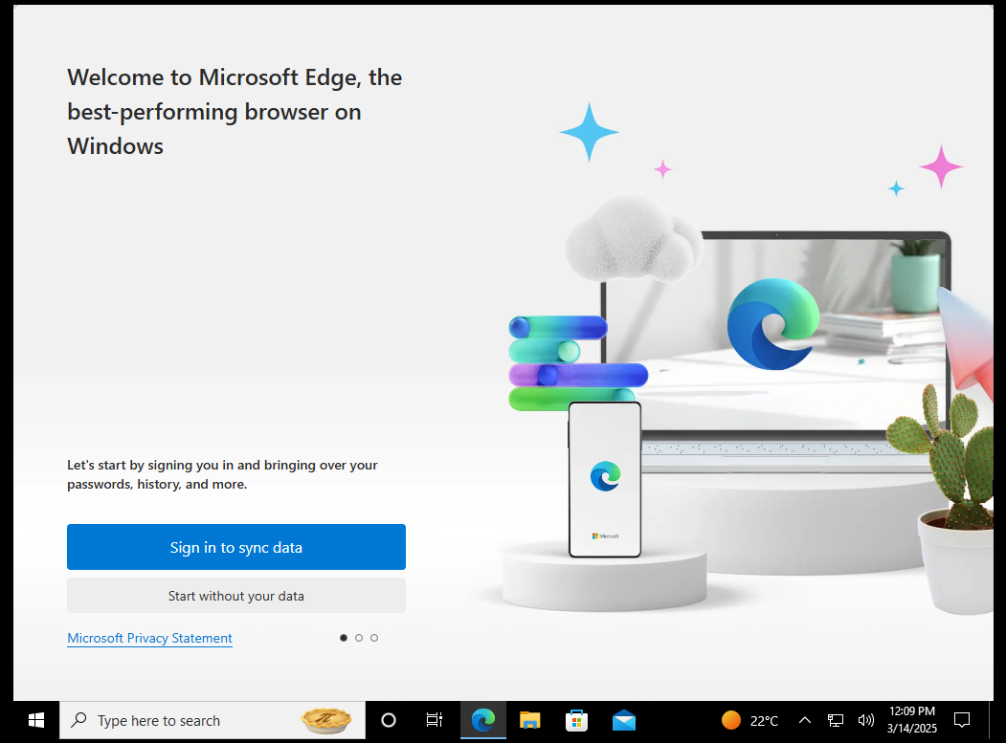

We can start our testing by login into windows server’s Group Policy Management.

The first GPO we are going to test is **Restrict access to control panel**.

We have moved the GPO to users because this policy is user configuration.

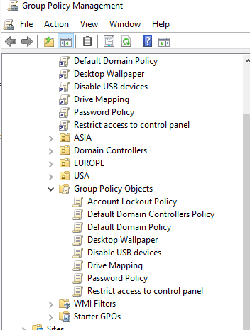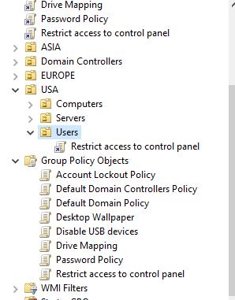



In the same way I moved the GPO Password Policy to computers because it is a computer configuration.

GPO’s named Drive mapping is a user configuration and Disable USB devices is a computer configuration.



USA where we moved our GPO’s to.

This Restriction shows our GPO is enabled.

In any case if our GPO is not working it means GPO is not updated as it sometimes take 90 minutes to refresh. 

In this case we need to to force update GPO through command prompt.



Now lets test Password Policy GPO by signing in with smaller password. 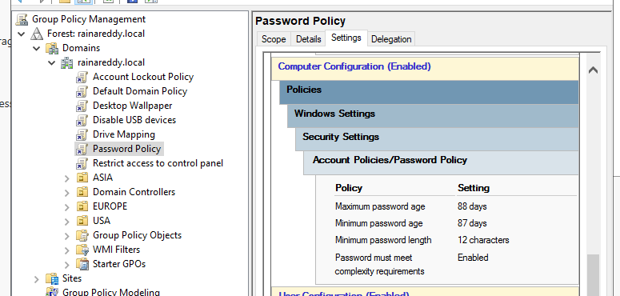



Lets login with a different user named sreenu jacson named cnu for login and I used the password sharan96 which is 4 characters short of password length. 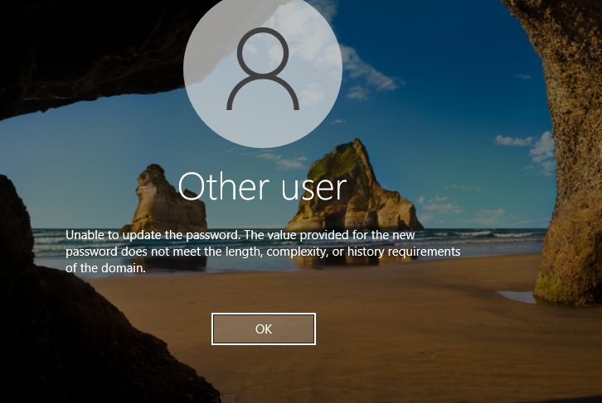

Successfully our GPO’s are working effectively.